- Listen to 3.1 and complete the text with the correct verbs from the box.
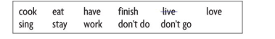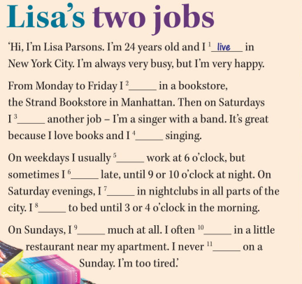

2. Complete the questions about Lisa and answer them.
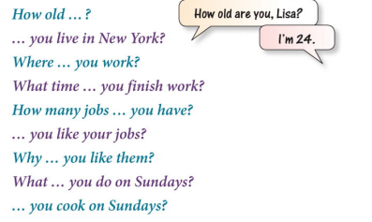

3.
